

1.Develop a system using UML for Personal Loan Management System. The admin should add new customers and view the customer's records. The admin should check the defaulters. The customer can see his/her account detail and apply for a new loan by providing the required documents, and payslip. The admin should verify the document submitted and approve the loan after verifying the payback potential of the customer.

AIM : To draw the UML diagrams for loan management system by using umbrello software.

USE CASE DIAGRAM :

i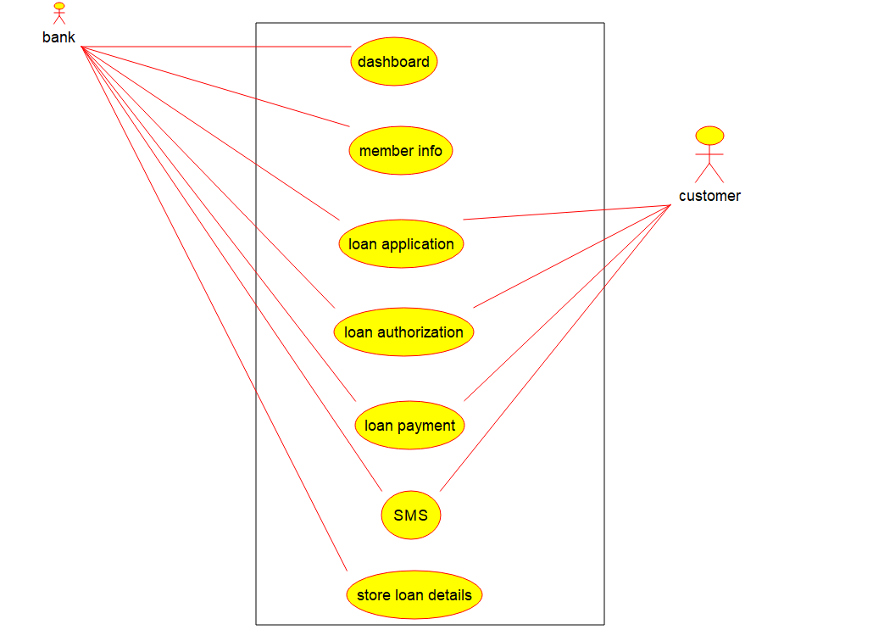

CLASS DIAGRAM :

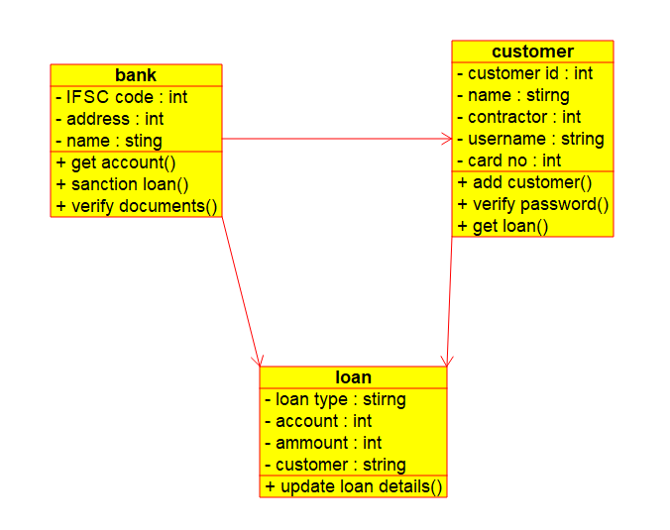

STATE CHART DIAGRAM :

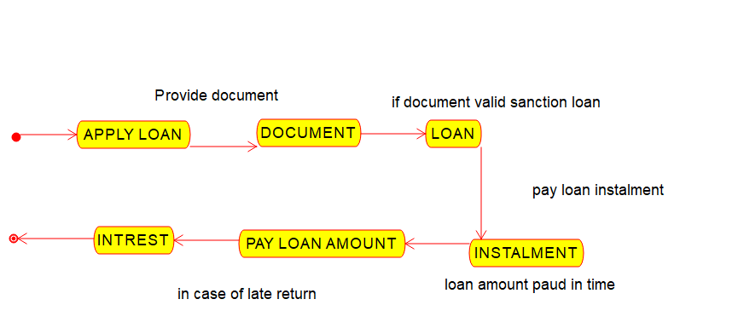

COMPONENT DIAGRAM :

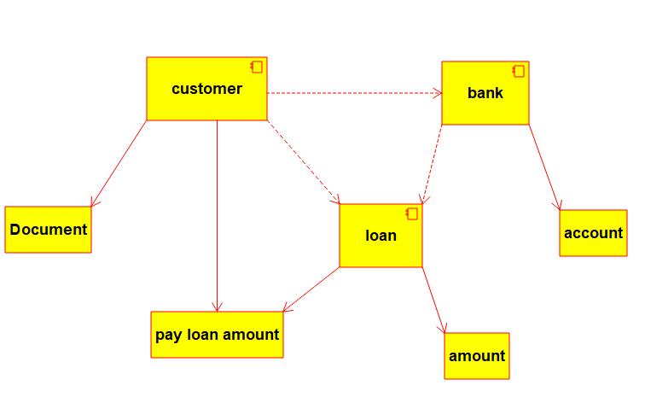

DEPLOYMENT DIAGRAM :

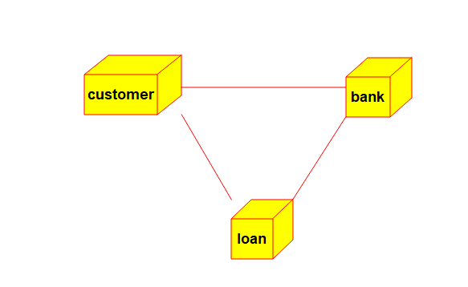

COMMUNICATION DIAGRAM :

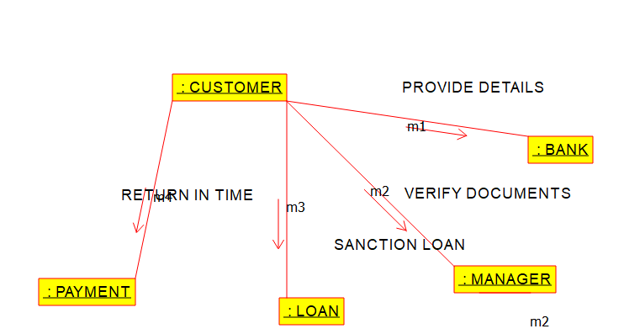

SEQUENCE DIAGRAM :

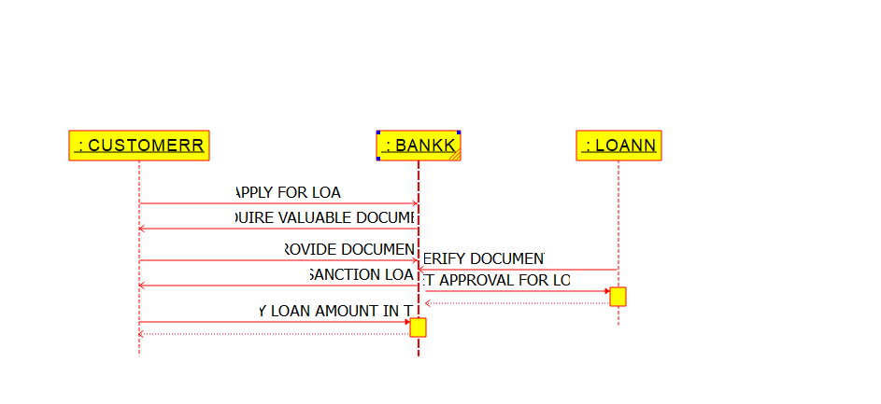

ACTIVITY DIAGRAM :

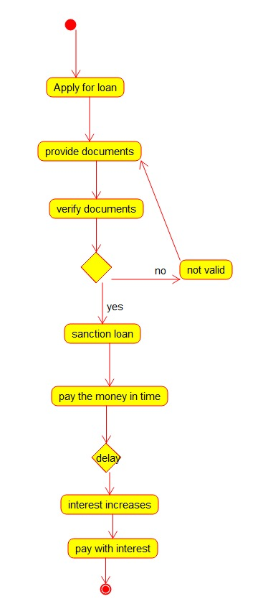

ENTITY RELATIONSHIP DIAGRAM :

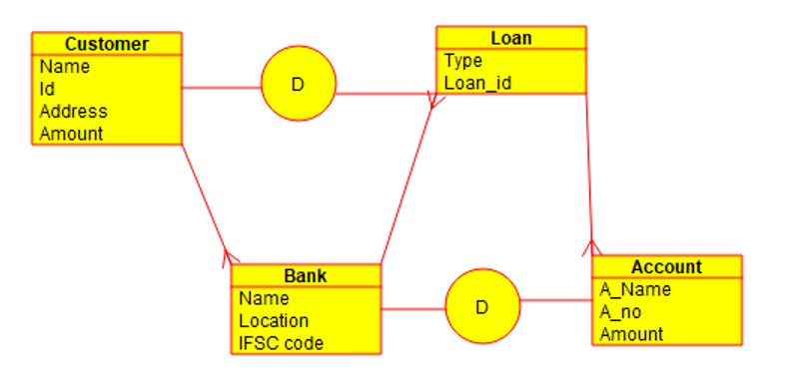

RESULT : Thus the UML diagram for loan management system has been implemented successfully by using umbrello software.